Internet Browsing Safety
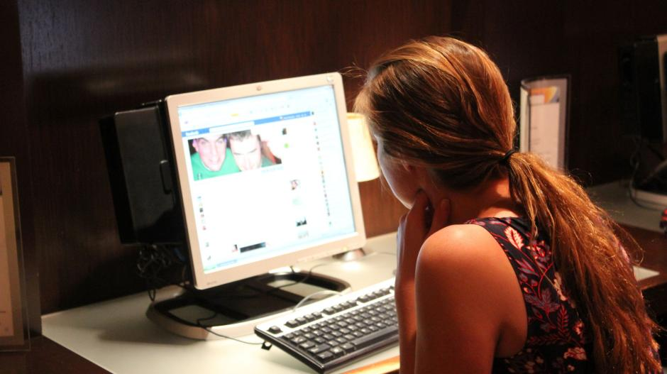

----------------------------------------------------------------------------------------------------------

Scenario 1:
Bill Smith added Mary Reese on Facebook. The same day he messaged her asking that she come over to his house. He sent her his home address in hopes that she would agree to this meeting. Though Mary has never met Bill in person and their only meeting has been through Facebook, Mary was happy to receive the attention and agreed to meet with Bill at his home.

- Discussion Questions:
  - What would you have done if you were Mary?
  - Do you think it okay for Bill to have asked her to meet him at his house, even though he never met Mary in person? Why or why not?

----------------------------------------------------------------------------------------------------------

Scenario 2:
Last week Angela Martin sent Todd Packer, a man who had just added her on Instagram, a rather risqué (naked) picture of herself in which she was not wearing all of her clothes. Angela did not bother to introduce herself before sending the picture and never met Todd in person. Last Friday Todd sent the picture to his friend Jim, who sent to his friend Michael.
- Discussion Questions:
  - What could Angela have done different in this situation?
  - Where did Angela go wrong?

------------------------------------------------------------------------------------------------------------

Scenario 3:
Barbara Ann saw an ad online that said her favorite movie, Despicable Me, was on sale for $5.99. Quickly, Barbara Ann reached for her wallet and began typing in her credit card. She became frustrated when she couldn’t watch the movie. Barbara Ann’s friend, Reba, called to ask her why she posted her credit card number so freely on Facebook. Shocked, Barbara Ann checked her profile, but it was too late… Christina Bryant, Barbara Ann’s Facebook friend, stole her credit card information and went on a shopping spree.
- Discussion Questions:
  - What could have stopped this from happening to Barbara Ann in the first place?
  - What should have happened before Barbara Ann entered her banking information?

------------------------------------------------------------------------------------------------------------

Scenario 4:
Betty Cooper “met” Archie Andrews on social media last year. They frequently talked of getting together but something would always get in the way of their plans. This Friday they have made plans and with nothing standing in their way it is likely they will finally meet.
Discussion Question: What are some steps Betty must take before meeting with Archie?

------------------------------------------------------------------------------------------------------------

Scenario 5:
Amanda Sanders sent Maggie Smith a nasty message online. She accused Maggie of “stealing her man, Troy Bolton,” as well as some other colorful language (cuss words). Maggie was shocked by what Amanda said because she had never met Troy in person. In fact, Maggie had never met Amanda either. Instead of politely answering back to her, Maggie used some choice words and cursed out Amanda for making such claims.
Discussion Questions:
- What should Amanda have done before saying Maggie (someone she had never met) of “stealing her man?”
- What should Maggie have said to Amanda in place of using choice (cuss) words?

