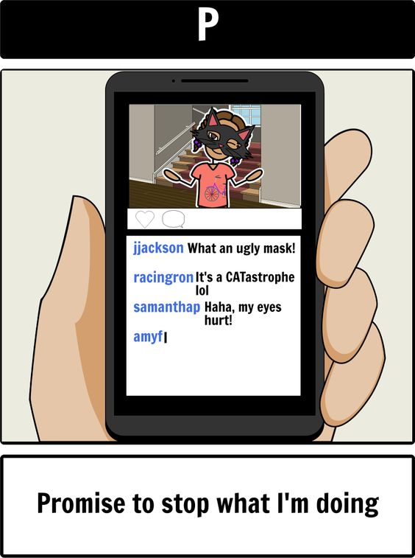

**Discussion**: Can you think of any examples of cyberbullying?

**What is cyberbullying?**

* Posting mean things about others
* Posting embarrassing pictures of others
* Posting lies or rumors about others

**Social Media Safety: Cyberbullying**



**Why should we NOT cyberbully?**

**Harms/Hurts Other Trouble with the Law**

  

**Why else should we not cyberbully?**

________________________________________________________________________________________________________________________________________________________________________________________________________________________________________________________________________________________________________________________________________________________________________

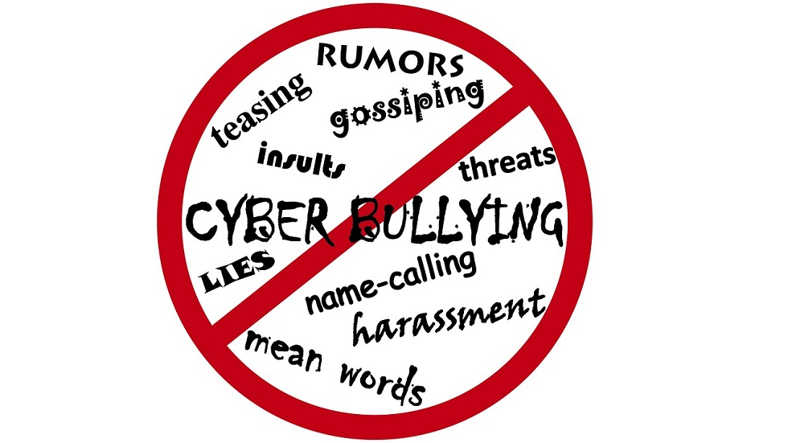

**What should we do if we see cyberbullying while on social media?**

**WHO CAN WE TELL?** 